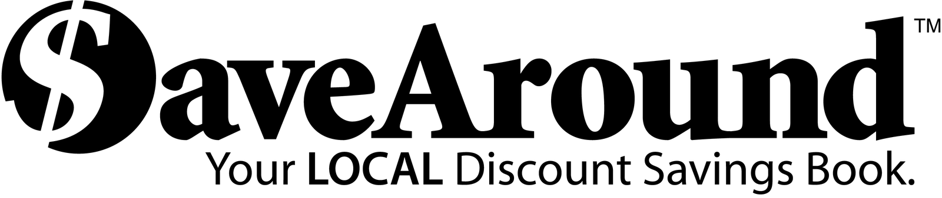

Dear Parents and Friends:
Burleigh Manor is sponsoring the SaveAround sale to raise funds that will help support school wide activities and student enrichment programs. SaveAround is a coupon book that offers hundreds of buy-one-get-one-free discounts, along with many other great discounts!!
You can buy one book for just $25!! The book pays for itself after you’ve used it just 2 or 3 times. You make your money back and more!!!

New this year, the SaveAround App!
Access your coupons from your device!

All proceeds from the fundraiser will help support school wide activities and student enrichment programs

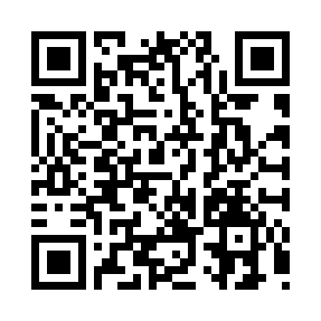
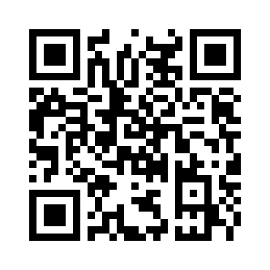
Start Date: Monday 12/18/17
End Date: Friday 1/5/18

View the Book Online
Copy and paste goo.gl/qXHdHT into your browser
2 Ways to purchase: View the Book Online Orders
- Complete the order form and return with payment to your child’s Science Teacher. The books will be delivered upon receipt.
- Order directly from SaveAround. Books will be delivered by mail. Copy and paste goo.gl/1wwVYA into your browser
Payment:
Cash
Checks: Please make checks payable to: BMMS
Online Payment: ONLINE PAYMENT IS STRONGLY ENCOURAGED!
For information and directions visit: bmms.hcpss.org and scroll down to
on line school purchases or click HERE or copy and paste goo.gl/A4LLHQ into your browser
Please include printed online receipt in your envelope.

FOR EVERY 5 BOOKS YOU SELL, YOU GET 1 FREE!!!

If you would prefer to make a donation, place your cash or check in an envelope and return to your child’s Science teacher marked
“Donation for 25th Anniversary Celebration.”

Coupon Book Order Form
Return this form to your Science teacher. Local books delivered immediately.

Student Name: ___________________
Grade: _________
Science Teacher: _____________________
For Books to be delivered through school
Customer Name: | Customer email | Book Code | Qty. of Books | Book Price | Total

